**<https://promys.org/Teacher-Recommendation-Form>**

[**https://www.txstate.edu/mathworks/camps/applications/teacher-recommendation.html**](https://www.txstate.edu/mathworks/camps/applications/teacher-recommendation.html)

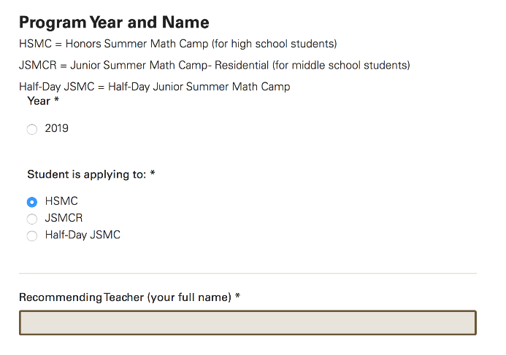

**Huang Ruiyan is a conscientious, hard-working student who arrives to class early every day and ready to learn Mathematics. This Math class is designed for Chinese local students from Grade 10. As one from Grade 9, she chooses to push herself and to always go the extra mile in this class. She uses one semester to study all the knowledge covered in Year 10 in local school by herself in order to catch up with others. She has a great passion for mathematics that shows through the resolve she puts into every single assignment. She conveys her thoughts and ideas clearly in her work. As a result, she scored high scores in all assignments. Her willingness to learn is very motivating. Sometimes she stays after class to ask for knowledge which is not covered in class but she is curious about. Also, she enjoys class discussions and is willing to try her best to offer her help to other students whenever they ask her any questions. She also does voluntary tutoring before exams from time to time for those who need help in Mathematics.**

**Outside of class, she also spends a lot of time digging into mathematical problems. As a result, she also won a lot of mathematical competitions. For instance, in 2017, her team came second in Berkeley Mathematical Tournament in the global final round; in 2018, she won the first price and got into the final the Math League but did go the final because of schedule conflict; She also won the second price in the 2017 National Junior High School Mathematics League. Also, she is planning to take AMC12 this year.**